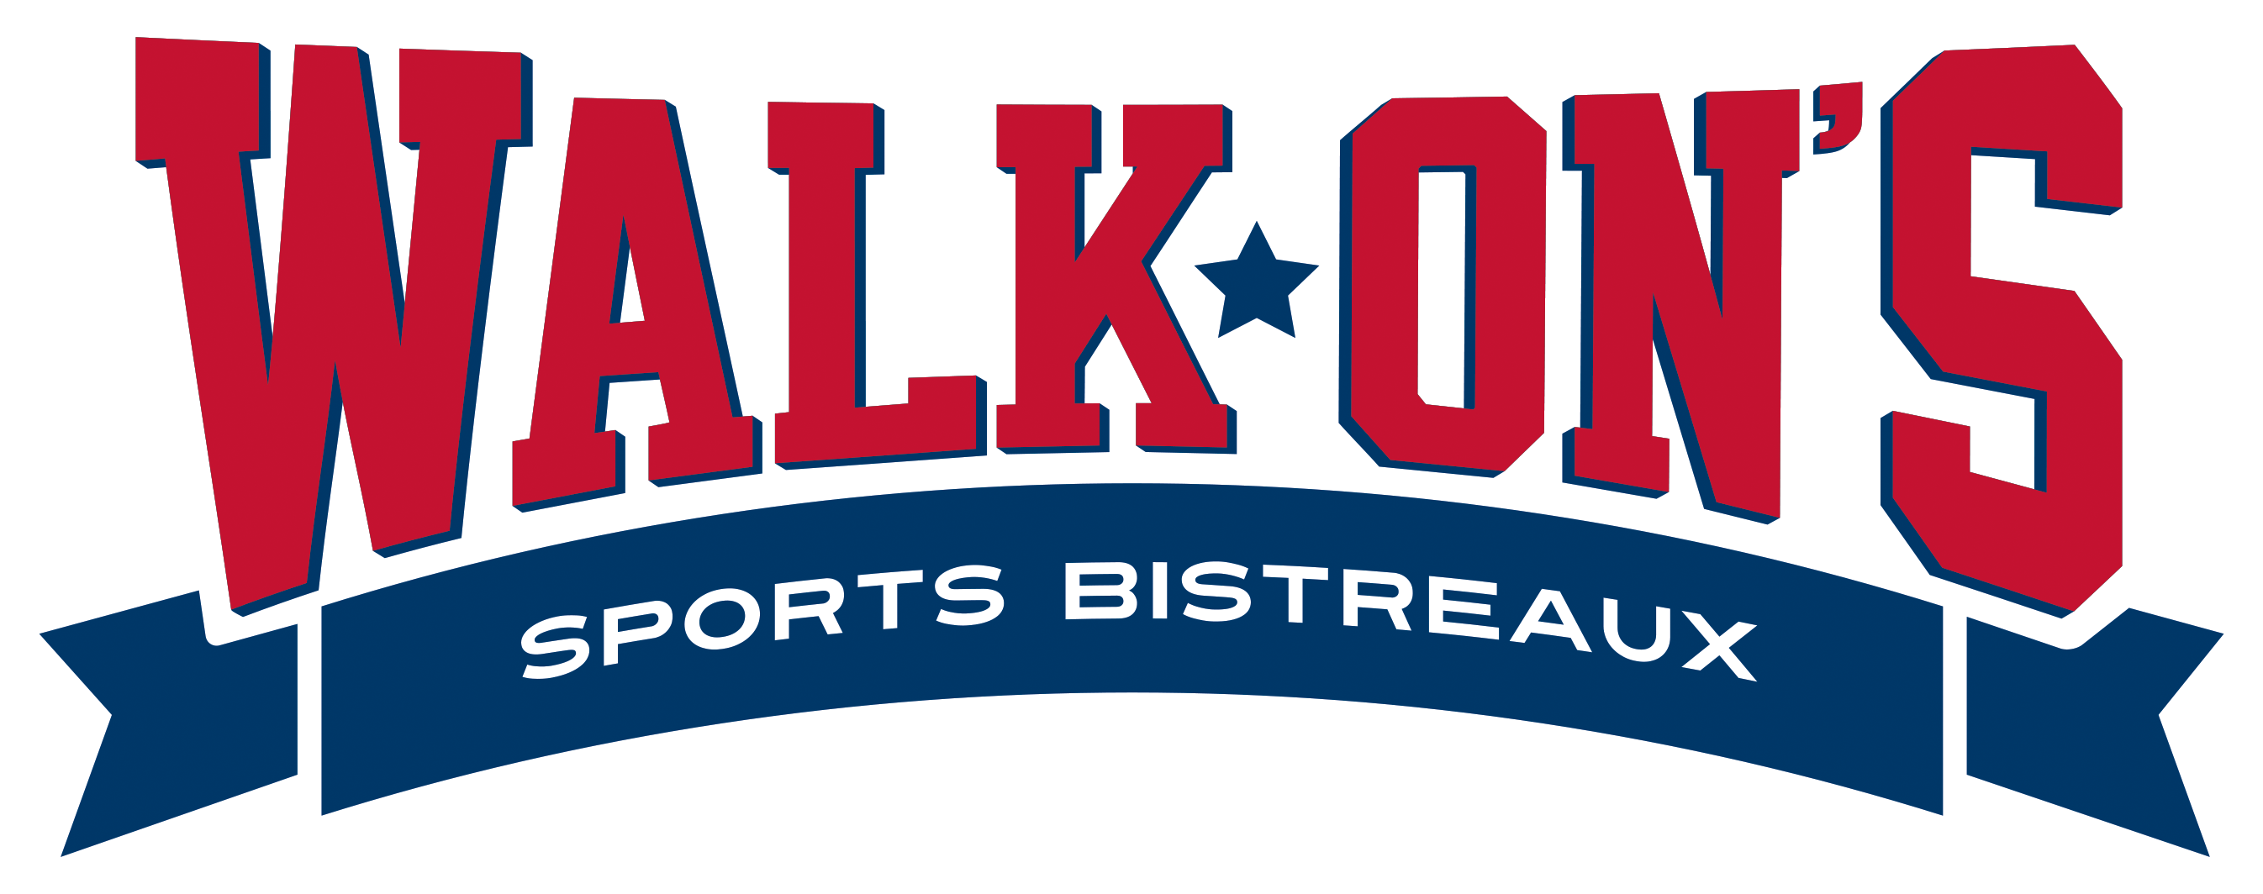

Walk On’s Burbank location is catering Kappa Sigma Fraternity event on 9/15/22 from 8:00 pm to 10:30 pm. Our staff will sell seltzers and beer only and abide to LSU Greek life rules. This includes no shots and no liquor.

Dustin Loveless

General Manager

225-603-9062